2025-2026
Mobile Computing
QR Guard – User Research & Impact Analysis Report

1️⃣ Introduction
QR Guard is an AI-powered URL security scanner designed to detect malicious and phishing links, especially those embedded in QR codes.
The system combines:
- A Machine Learning Random Forest model
- Advanced URL feature extraction
- Shannon Entropy analysis
- Suspicious keyword detection
- Integration with VirusTotal API
The goal of this research is to evaluate user awareness of phishing attacks and identify the most important features that increase trust in a URL security scanner.

2️⃣ Survey Methodology
A structured online survey was conducted to analyze user awareness, security concerns, and trust preferences.
- Total Responses: 15 valid participants
- Target Groups:
  - General Users
  - Students
  - IT / Cybersecurity users
The survey included:
- Multiple choice questions
- Awareness rating (1–5 scale)
- Trust and feature preference questions

3️⃣ Survey Results & Key Insights
🔹 User Background
Participants included:
- General Users (majority)
- Students
- IT / Cybersecurity users
🔹 Awareness Level
Most users showed medium awareness (3–4 out of 5) regarding phishing attacks.
🔹 Main Security Concerns
- Phishing (highest concern)
- Malware
- Data leakage
- Account theft
🔹 Scanner Trust Preferences
- Majority trust VirusTotal integration
- Fewer users trust standalone ML only
- Some prefer a combined approach
🔹 Most Requested Features
- VirusTotal integration
- Detailed explanation of results
- Fast scanning
- AI confidence score
🔹 Behavioral Insight
Not all users verify links before clicking, indicating the need for:
- Simple interface
- Clear Safe/Danger verdict
- Encouraging pre-click scanning behavior

4️⃣ User Personas
👤 Persona 1 – Omar (General User)
Profile:
- Age: 22
- Field: General User / Student
- Tech Level: Medium
Awareness Level: Moderate
Main Concern: Phishing attacks
Goals:
- Know if a link is safe before clicking
- Avoid account theft
Needs:
- Clear Safe/Danger result
- Fast scanning
- Minimal technical details
Quote:
“Just tell me if it’s safe before I click.”

👩 Persona 2 – Salma (Security-Oriented User)
Profile:
- Age: 23
- Field: IT / Cybersecurity
- Tech Level: Advanced
Awareness Level: High
Main Concerns: Malware and data leakage
Goals:
- Understand why a URL is flagged
- See confidence score
- Rely on trusted sources like VirusTotal
Needs:
- Detailed explanation
- AI confidence percentage
- VirusTotal integration
Quote:
“I need technical justification before trusting the result.”

5️⃣ Impact Map
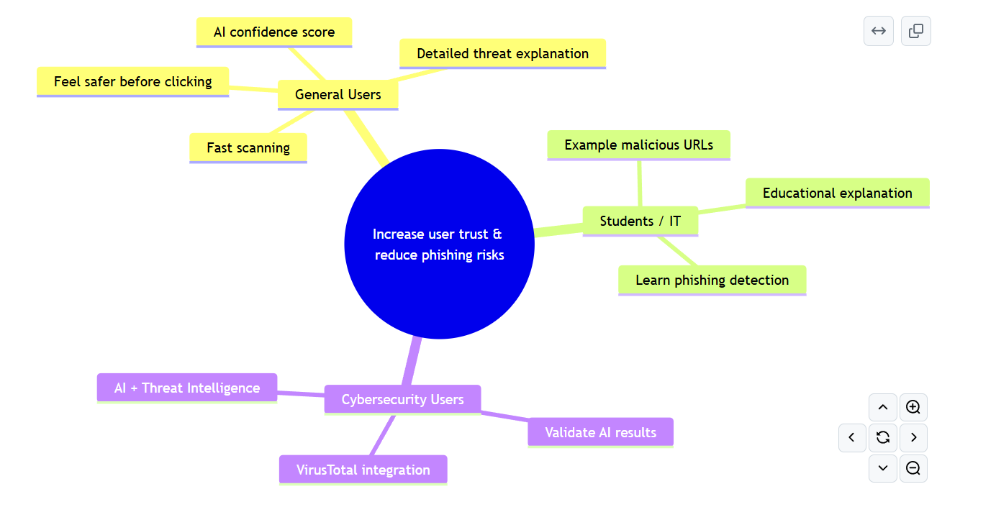
🎯 GOAL
Reduce phishing and malicious URL risks from QR codes and suspicious links.
👥 ACTORS
- General Users
- Students
- Cybersecurity Users
📈 IMPACTS
- Increase phishing awareness
- Reduce risky clicks
- Increase trust in AI-based security tools
- Encourage link verification before access

⚙ FEATURES
- Machine Learning URL classification
- Entropy-based detection
- Suspicious keyword detection
- VirusTotal API integration
- Combined AI + VirusTotal verdict
- Clear Safe/Danger interface
- Confidence score display

6️⃣ Conclusion
The survey results confirm that users are concerned about phishing and malicious links but require different levels of detail depending on their technical background.
QR Guard addresses these needs by combining AI-based detection with VirusTotal integration and providing both simple verdicts and detailed technical explanations.

